Report by: 1409046  
Role: Level Design & Artist liaison

Game Version: Latest – with Menus  
Date Reported: 08/05/2016

QA Status: Passed

Severity: Minor

Priority: Moderate

Test Introduction:

The purpose of this test was to check that correct scene was reloaded from level 2. To test this, I played through level 2 and pressed ‘Replay level’.

Expected outcome:

Level 2 would be reloaded.

Actual outcome:

When I clicked the replay button it loaded level one again.

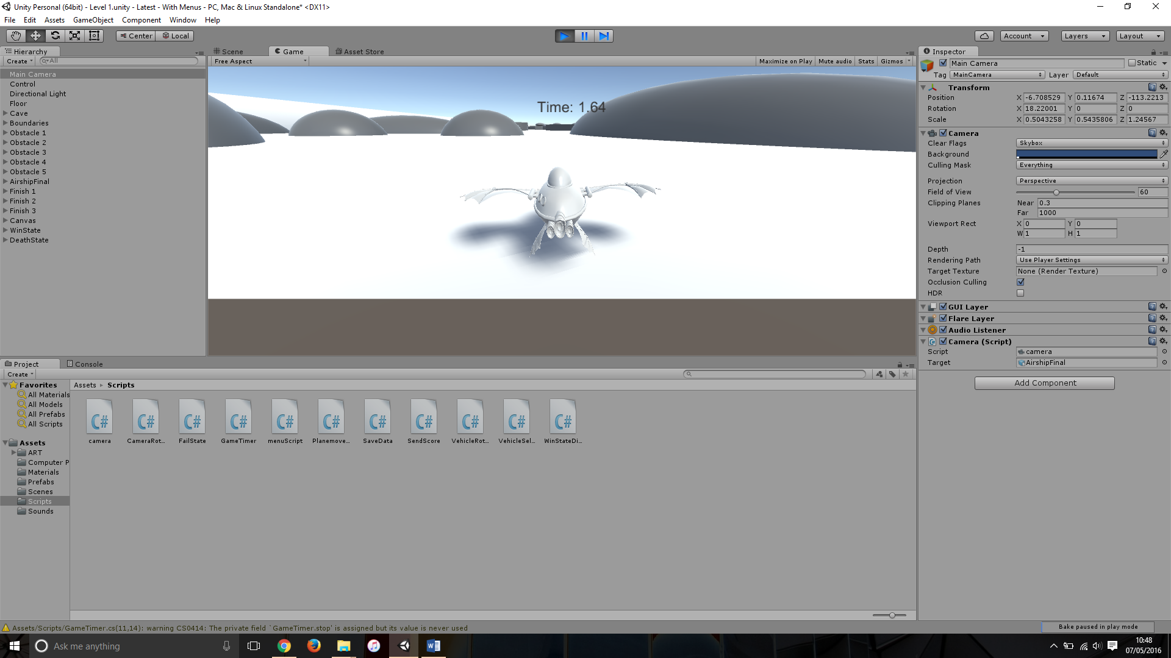Screenshot of the bug:

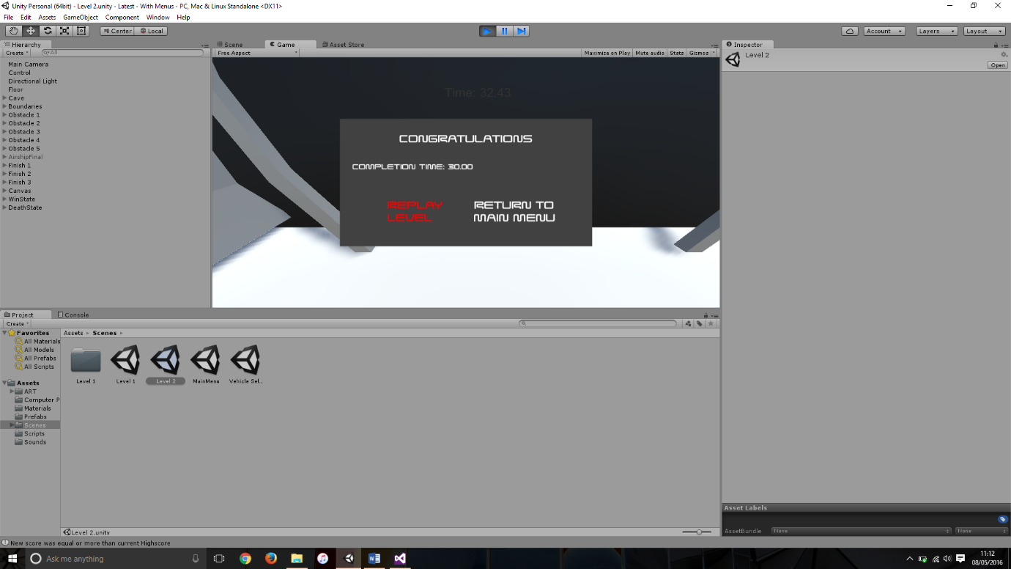Image showing the sequence of events when the ‘Replay level’ button is selected.

Potential cause:

A potential cause for this bug could be that the script is calling a level by name or number from the first level, meaning it would always be loading the 1st level.

Another cause for this bug could be that because scene 2 is a direct copy of scene 1 the ‘OnClick’ event could just be pointing to level 1.

Suggested Fix:

To fix this bug I had to change a line within ‘WinStateDisplay’ from Application.LoadLevel(2); to Application.LoadLevel(Application.loadedLevel); this line was originally calling the 3rd scene within the build but now is reloading the scene that was originally loaded.